**Assignment 1: TechShop, an electronic gadgets shop**

**Task 1:Database design.**

**1)Create the database named "TechShop"**

* For creating a database you need a command called “Create database database name;

Eg: create database Assignment1;

And for storing data you need to use the database by using command called use database.

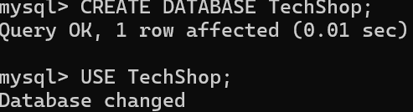

**2)Define the schema for the Customers, Products, Orders, OrderDetails and Inventory tablesbased on the provided schema**.

* For defining the schema you need to create tables for the each and every mention in the list .
* For that you need a **DDL command called create** the output after creating all the commands can be viewed using  **desc table and show tables command**

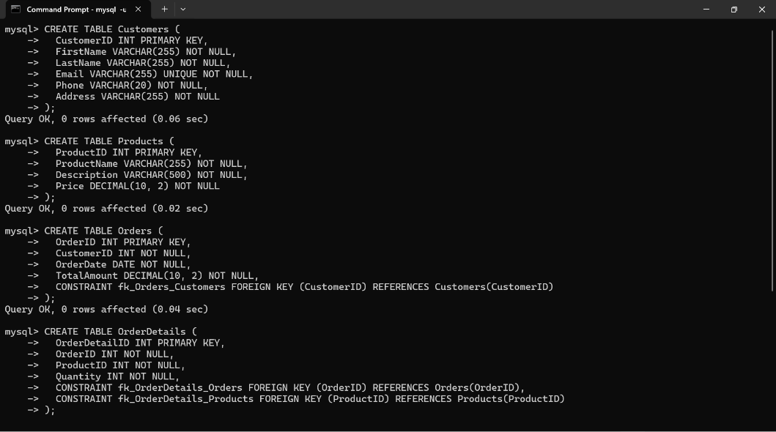

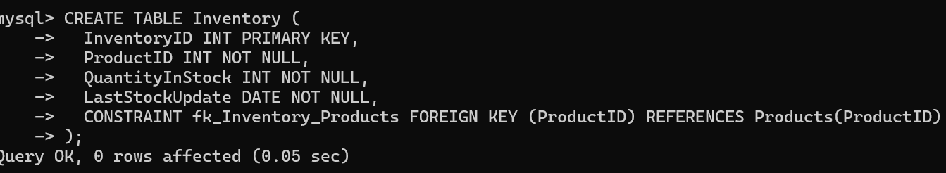

**3)Create an ERD (Entity Relationship Diagram) for the database  
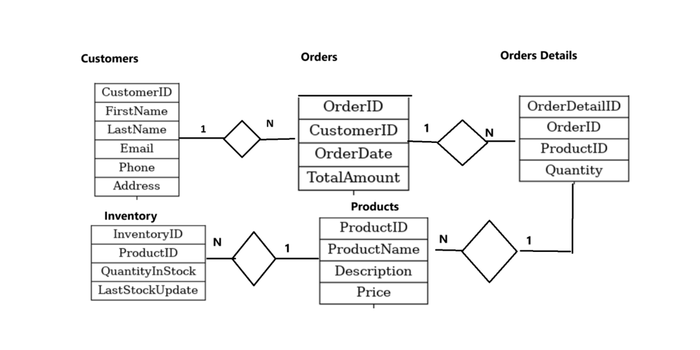**

**4)Create appropriate Primary Key and Foreign Key constraints for referential integrity**

* Already while creating the table we have to mention about the required keys like primary key and foreign key . so at the time of creating table we have to mention.

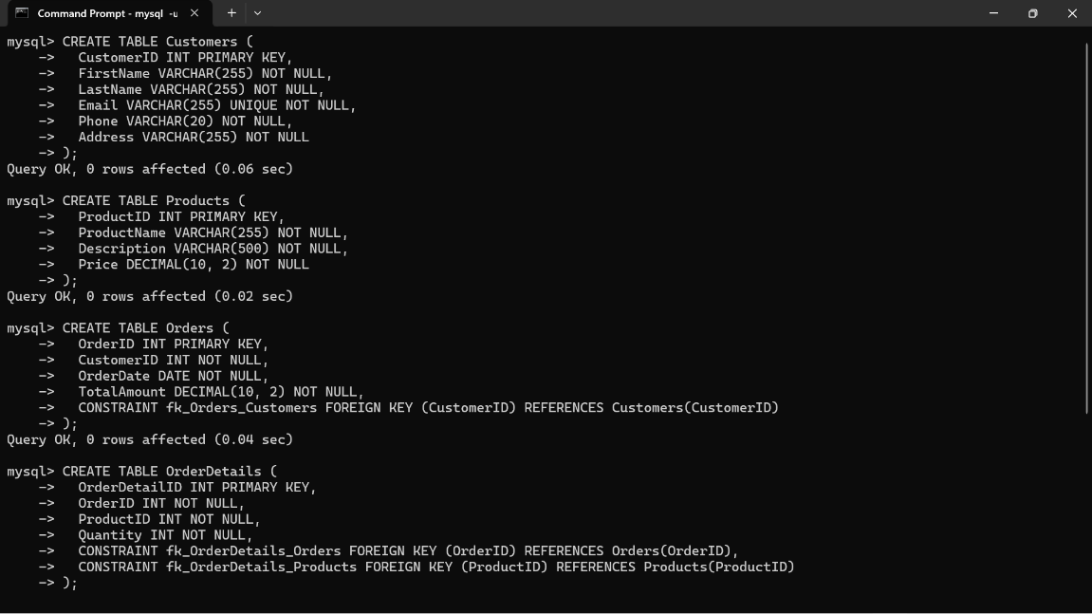

**Insert at least 10 sample records into each of the following tables.**

**a. Customers**

**b. Products**

**c. Orders**

**d. OrderDetails**

**e.Inventory**

* To insert the data into values the respective tables we have use a **DMl command called Insert.** The query looks like : **INSERT INTO Customers (CustomerID, FirstName, LastName, Email, Phone, Address)VALUES**( enter the values according to it.
* The following is for the insertion of data for customers table.

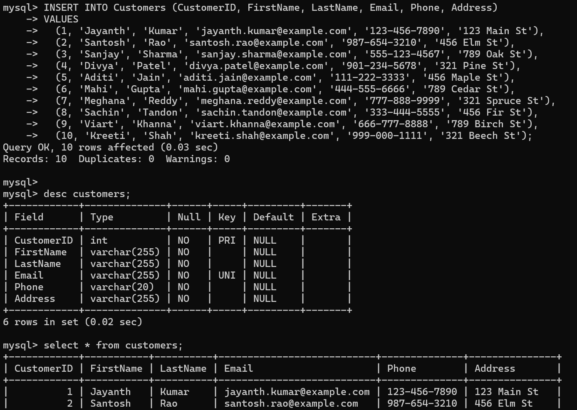

The following is for the insertion of data for Products table:

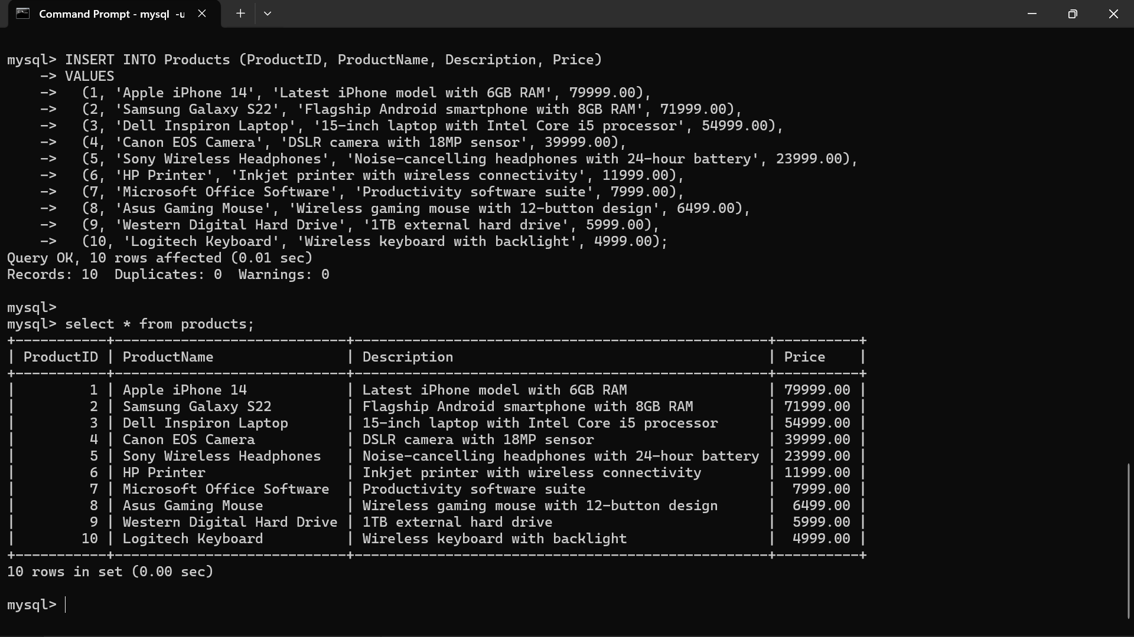

The following is for the insertion of data for orders table:

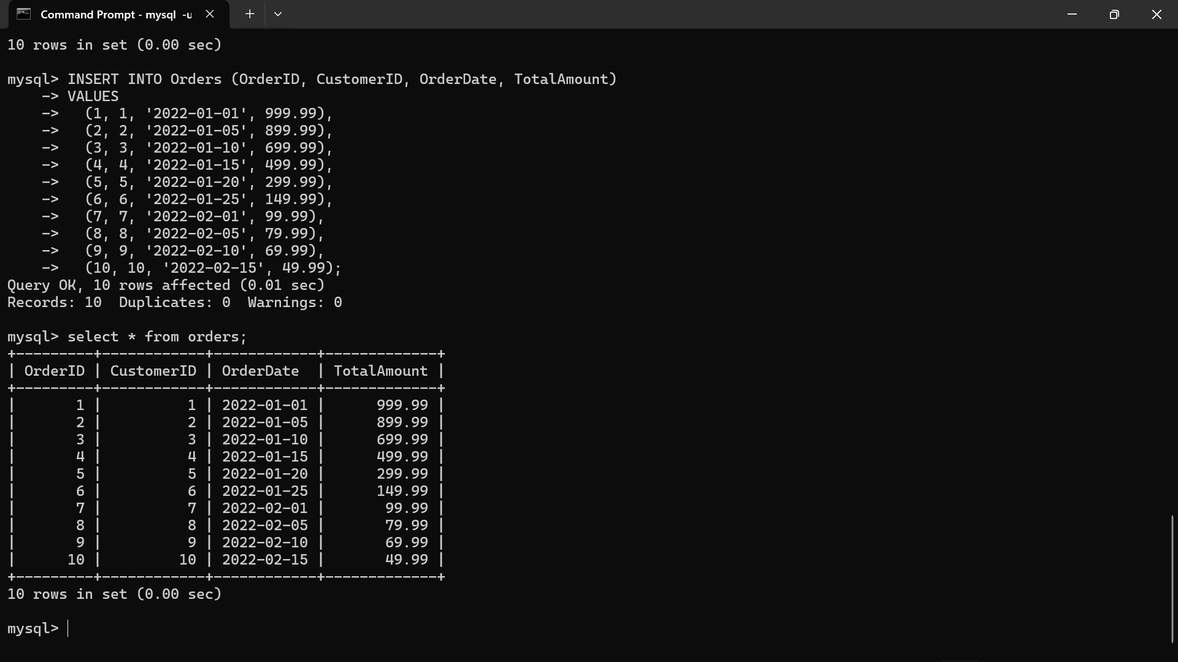

The following is for the insertion of data for orderDetails:

The following is for the insertion of data for Inventory table:

**Tasks 2: Select, Where, Between, AND, LIKE:**

**1)Write an SQL query to retrieve the names and emails of all customers.**

* To retrieve the names and emails of all customers we can use  **we can use the select statement followed by the first name and last name and email address from customer table .**
* The query looks like this **SELECT FirstName, LastName, Email FROM Customers;**

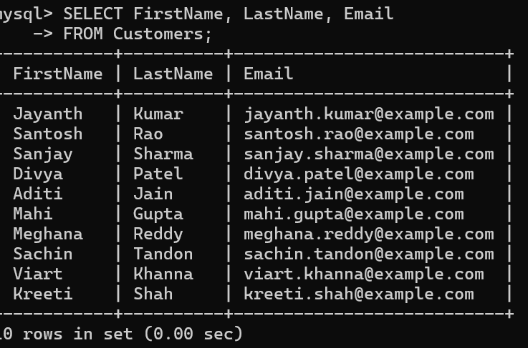

**2)Write an SQL query to list all orders with their order dates and corresponding customer names.**

* To retrieve the list of all orders with their order date and corresponding customer  
  you can use the join command as alias for easy retrieval of data
* SELECT O.OrderID, O.OrderDate, C.FirstName, C.LastName FROM Orders O JOIN Customers C ON O.CustomerID = C.CustomerID;

**3)Write an SQL query to insert a new customer record into the "Customers" table. Include customer information such as name, email, and address**

* To insert the new customer record we can use insert into table name and values.  
  the Query looks like **:** **INSERT INTO Customers (CustomerID, FirstName, LastName, Email, Phone, Address)**
* **VALUES (11, 'Rahul', 'Sharma', 'rahul.sharma@example.com', '888-888-8888', '123 New Street');**

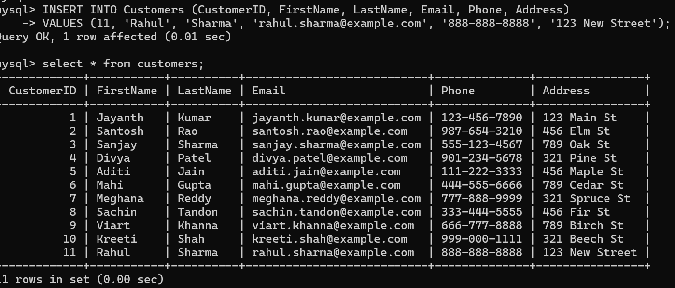

**4)Write an SQL query to update the prices of all electronic gadgets in the "Products" table by increasing them by 10%.**

* To update the prices of all electronic gadgets in products we can use **DML** command called update and the query looks like : **UPDATE Products SET Price = Price * 1.10;**

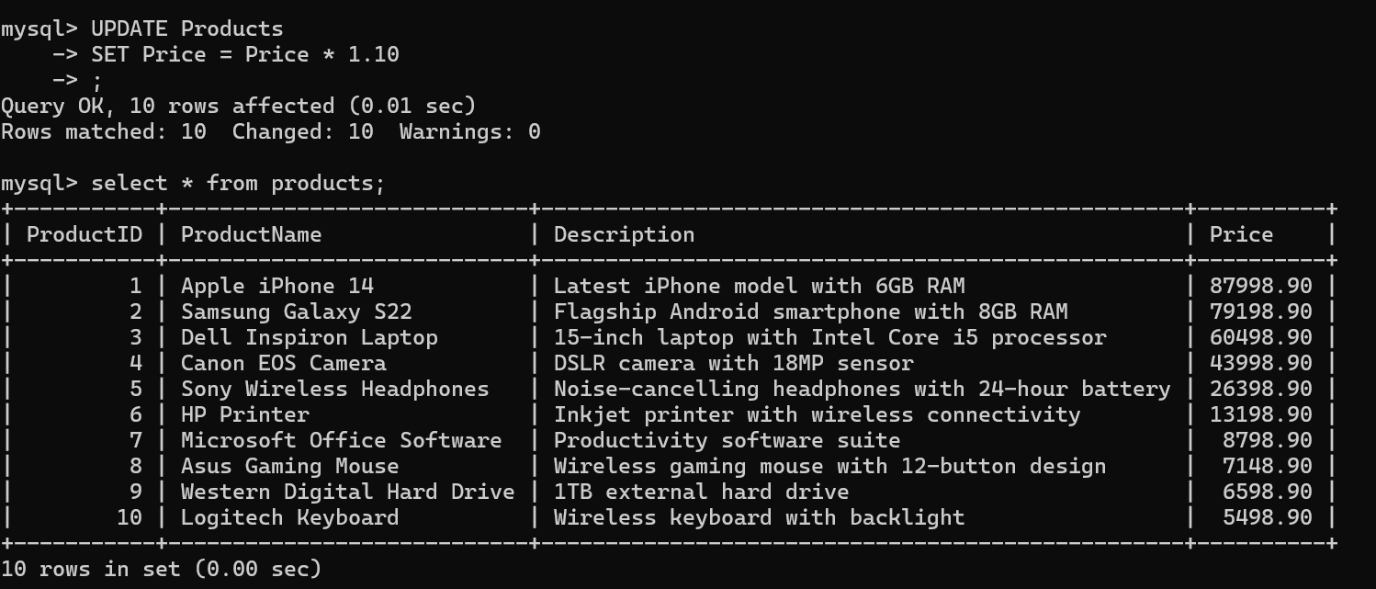

**5)Write an SQL query to delete a specific order and its associated order details from the "Orders" and "OrderDetails" tables. Allow users to input the order ID as a parameter.**

* The sql query for the delect a specific order and its associated order details from the “order and Order details”

**DELETE FROM OrderDetails WHERE OrderID = @OrderID; and**

**DELETE FROM Orders WHERE OrderID = @OrderID;**

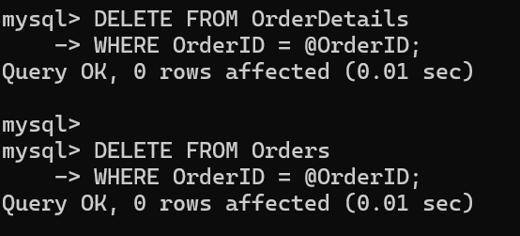

**6. Write an SQL query to insert a new order into the "Orders" table. Include the customer ID, order date, and any other necessary information**

* To insert a new order into the orders table include the customer ID order date we can use insert into table name value( enter the values) .
* The query looks like this **INSERT INTO Orders (OrderID, CustomerID, OrderDate, TotalAmount) VALUES (11, 1, '2022-03-01', 999.99);**
* **INSERT INTO OrderDetails (OrderDetailID, OrderID, ProductID, Quantity) VALUES (11, 11, 1, 1);**

**7. Write an SQL query to update the contact information (e.g., email and address) of a specific customer in the "Customers" table. Allow users to input the customer ID and new contact information.**

* To update the customer details we can use the update Command of DML command and the query looks like:
* **UPDATE Customers SET Email = ‘rahul@gmai.com’, Address = ‘12345 goa’ WHERE CustomerID = 10;**

**8)Write an SQL query to recalculate and update the total cost of each order in the "Orders" table based on the prices and quantities in the "OrderDetails" table.**

* To recalculate and update the total cost of each order we can use update and set order such that we can only calculate the total cost of the order in order table
* The query looks like this: **UPDATE Orders O SET TotalAmount = ( SELECT SUM (OD.Quantity * P.Price)FROM OrderDetails OD JOIN Products P ON OD.ProductID = P.ProductID WHERE OD.OrderID = O.OrderID);**

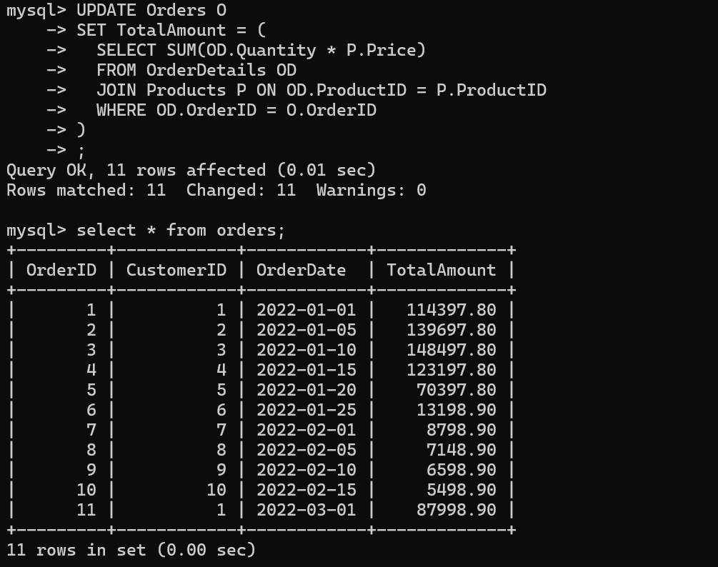

**9)Write an SQL query to delete all orders and their associated order details for a specific customer from the "Orders" and "OrderDetails" tables. Allow users to input the customer ID as a parameter.**

* The Sql query for the delete all orders and their associated order details for a specific customer from orders and orderdetails table is :
* **DELETE FROM OrderDetails WHERE OrderID IN (SELECT OrderID FROM Orders WHERE CustomerID = 9);**
* **DELETE FROM Orders WHERE CustomerID = 8;**

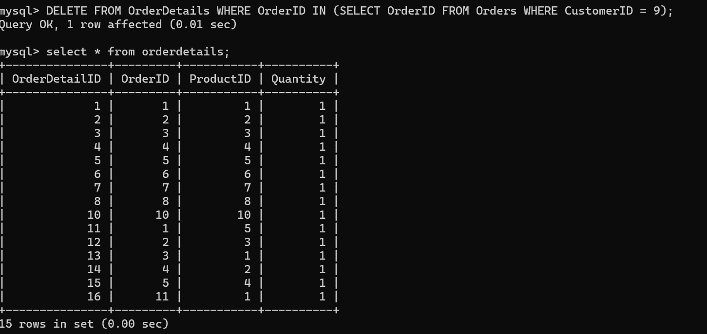

**10. Write an SQL query to insert a new electronic gadget product into the "Products" table, including product name, category, price, and any other relevant details.**

* The sql query for the insert a new electronic gadget product into products table including product name and price is :

**INSERT INTO Products (ProductID, ProductName, Price, Description)**

**VALUES (11, 'New Gadget', 799.99, 'Latest electronic gadget');**

**11. Write an SQL query to update the status of a specific order in the "Orders" table (e.g., from "Pending" to "Shipped"). Allow users to input the order ID and the new status.**

* The sql query to update the status of a specific order in the orders table like pendhing to shipped is :

Note we can update the data but first we have to create the column to update the record so for that the query is **UPDATE Orders**

**SET Status = ‘shipped’**

**WHERE OrderID = 2;**

**12)Write an SQL query to calculate and update the number of orders placed by each customer in the "Customers" table based on the data in the "Orders" table**

* The sql query to calculate and update the number of orders placed by each customer in customers table based on the order table is we can do it by using the
* **SELECT C.*, COUNT(O.OrderID) AS OrderCount FROM Customers C LEFT JOIN Orders O ON C.CustomerID = O.CustomerID GROUP BY C.CustomerID;**

